Neural Network Basics – Anish Mahapatra

When you have a dataset with many rows, we would not want to use a for loop to iterate over them one by one.

Using Logistic Regression for Binary Classification. 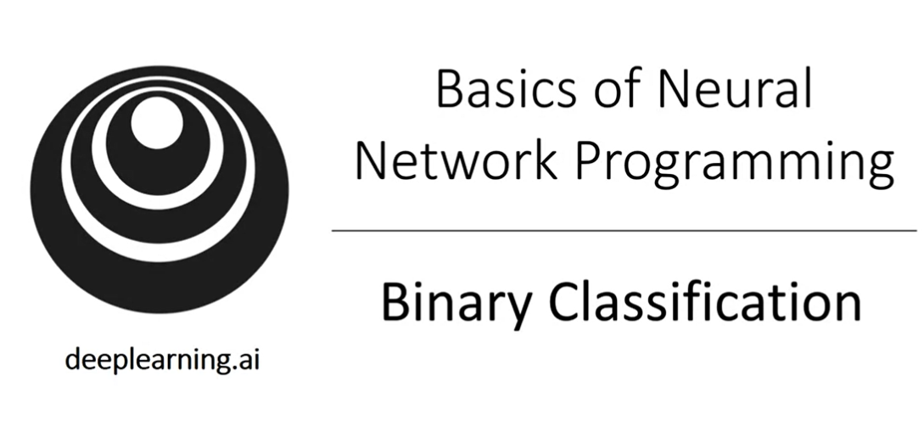

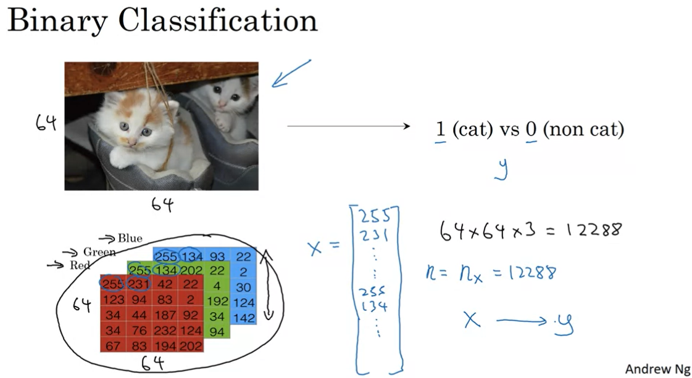

Notation:

M training examples: (x1, y1), (x2, y2) .. (xm, ym)  
M train, M test  
X is a n x m matrix. N Rows, M columns

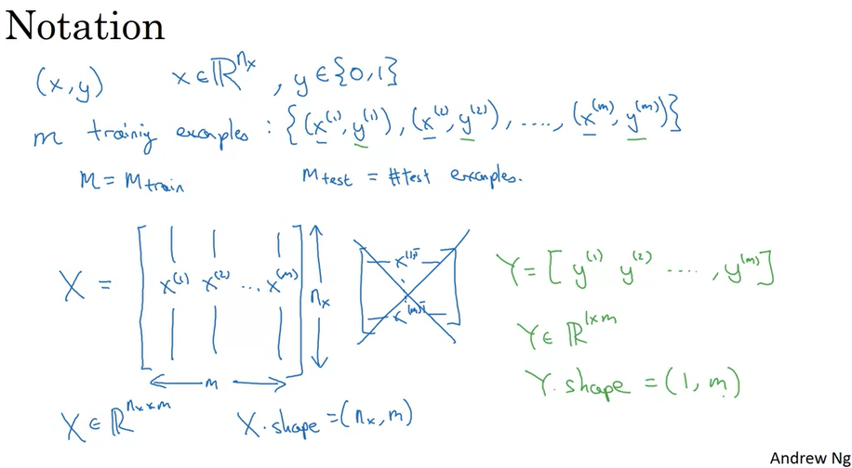

Derivation of Logistic Regression

